Technical Seminar Report

On

**MERN STACK**

Submitted to

Jawaharlal Nehru Technological University, Hyderabad

*In Partial Fulfillment of the requirements for the Award of Degree of*

**BACHELOR OF TECHNOLOGY**

**IN**

**COMPUTER SCIENCE AND ENGINEERING**

Submitted

By

**Thani Chandu**

**(198R1A05N1)**

Under the Esteemed guidance of

**Mrs. Amita Mishra**

Professor, Department of CSE

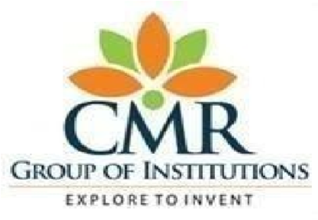

**Department of Computer Science & Engineering**

**CMR ENGINEERING COLLEGE**

(Approved by AICTE, NEW DELHI, Affiliated to JNTU, Hyderabad)

Kandlakoya, Medchal Road, R.R. Dist. Hyderabad-501 401

**2022-2023**

**CMR ENGINEERING COLLEGE**

*(Accredited by NBA, Approved by AICTE NEW DELHI, Affiliated to JNTU, Hyderabad)*

*Kandlakoya, Medchal Road, Hyderabad-501 401*

**Department of Computer Science & Engineering**



**CERTIFICATE**

This is to certify that the seminar entitled **“MERN STACK”** is a bonafide work carried out by

**Thani Chandu (198R1A05N1)**

In partial fulfillment of the requirement for the award of the degree of **BACHELOR OF TECHNOLOGY** in **COMPUTER SCIENCE AND ENGINEERING** from CMR Engineering College, affiliated to JNTU, Hyderabad, under our guidance and supervision.

|  |  |  |
| --- | --- | --- |
| Internal Guide | Seminar Coordinator | Head of the Department |
| **Mrs. Amita Mishra** | **Mr. Mrutyunjaya Yalawar** | **Dr. Sheo Kumar** |
| Professor | Assistant Professor | Prof & H.O.D |
| Department of CSE | Department of CSE | Department of CSE |
| CMREC, Hyderabad | CMREC, Hyderabad | CMREC, Hyderabad. |

**ACKNOWLEDGMENT**

We are extremely grateful to **Dr. A. Srinivasula Reddy**, Principal and **Dr. Sheo Kumar**, HOD,

**Department of CSE, CMR Engineering College** for their constant support**.**

I am extremely thankful to **Mrs. Amita Mishra,** Professor, Internal Guide, Department of CSE, for her constant guidance, encouragement and moral support throughout the project.

I will be failing in duty if I do not acknowledge with grateful thanks to the authors of the references and other literatures referred in this Project. I express my thanks to all staff members and friends for all the help and co-ordination extended in bringing out this Project successfully in time.

Finally, I am very much thankful to my parents who guided me for every step.

|  |  |
| --- | --- |
| **Date:** | **Thani Chandu** |
| **Place: Hyderabad** | **(198R1A05N1)** |

# MERN Stack

The individual elements of the MERN stack were each developed separately to address different development tasks commonly associated with JavaScript. Node.js was developed in 2009 to serve as a scalable run-time framework for running JavaScript code outside a web browser. Express.js was developed over a year later to serve as a de-facto server framework for Node.js applications. MongoDB was developed in 2009 to create a JavaScript native database documentation framework. React was introduced in 2013 as a framework for building and repurposing component UI elements. Node.js, in particular, will be very useful for building single-page applications, and neither Ruby on Rails or Django readily replicate this functionality. This means that more elaborate event-driven web applications, particularly those which run chat features or in-app browser games, will benefit from the MERN stack framework.

# Introduction

MERN stack is an acronym for a full stack JavaScript framework consisting of MongoDB, Express.js, React, and Node.js. It is among the most common full stack frameworks available and is prevalent in web development projects utilizing JavaScript. Learning the MERN stack is an ideal way to start a career in full stack web development, though these are advanced skills, so you’ll need some existing programming knowledge. MERN is only one of several full stack development frameworks that coders can learn and use, so students will want to consider the kinds of projects they are working on when selecting the first framework to study. Students looking to learn the MERN stack can visit Noble Desktop to learn all about their comprehensive MERN and JavaScript courses, which are available both live online and in person at Noble’s Manhattan campus.

## MERN Stack Architecture

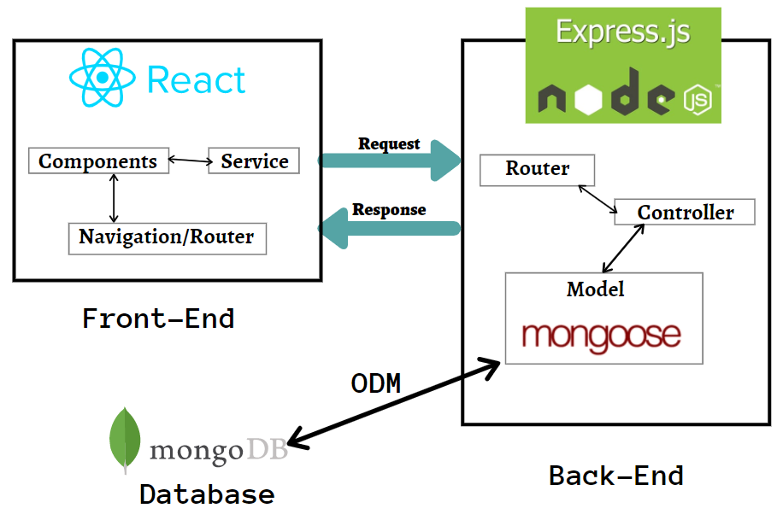

## Classification Of MERN stack

This kind of stack is used for building single-page applications. It means a web application that interacts with the user dynamically by just rendering the current page with requested data.

Ex: if you log in to your Gmail account (by default, the inbox page rendered while opening the Gmail page) and then tapping on the Sent mail section, it simply overwrites the Inbox column instead of opening the new window.

The essential operation in a web page/application is CRUD (Create, Read, Update, Delete). It facilitates the MVC (Model-View-Controller) architecture that makes the web development process work smoothly.

## 

It consists of three parts:

**Front End:**

We know this part concentrate on user interaction. JS has a potential hand for event handling and loading all content in one web page due to DOM. Specifically, all content loaded by AJAX — the method of exchanging and updating the data in an application without refreshing the page.

**REACT – Pure UI:  
A Scenario:** Consider the GitHub website, where I can see a landing page, my repositories, and its details. This part is considered as a component in react.js.

If I wish to make changes in an existing repository then I click on that repo and I will make changes(eg: adding files). This part is called Service in react.js.If we navigate from the landing page to existing repo content then this is called navigation/ router in react.js.

**Component** — related to appearance or rendering of the content.

**Services**— CRUD operations are done based on the user’s request and responses are rendered based on the result.

**Navigation/router** — navigation among various components. Eg: clicking on Submit button to render the landing page. We need this notable concept because single-page automation will render the component within the component.

Simply in an application, different pages are navigated through **the router**. During the router, **components** will be generated. If data to be fetched from server or crud operation are facilitated by **services**.

**Axios - Third party library**

We know React is a pure UI that helps to build attractive web pages but for server-side communication, we need a third-party library. Axios acts as an HTTP client library and contains all HTTP methods for communication. Request from react for fetching data are requested as HTTP using Axios to the server-side. There are other libraries like Axios are there but this is used widely.

# Back End

This part contains **Node.js, Express.js**.

* This plays a major role in single page application. JS helps to build our application more interactive. JS code is first interpreted by JavaScript Engine and renders the appearance. Simply, we call it DOM-based execution. If you think we have only one kind of JavaScript engine then it is mistaken. We have multiple browsers, so each browser has its engine.
* Eg: Chrome — V8, Internet Explorer — Chakra, Edge — V8(chromium-based), Mozilla Firefox — SpiderMonkey. Node.js is neither an application nor a framework. It’s just a runtime environment built on a standalone machine to interpret JavaScript code. It runs on top of the JavaScript Engine.
* To make this engine a server-side component, we have included HTTP modules within it. Since many modules are built-in and others are external dependencies. If you need then you can download it from npm (node package manager). npm used for downloading packages of front-end and back-end .

## Express.js

**Node.js is just a runtime environment then How does the client communicate with the server?**

**How does the server act on the request and send responses?**

The answer is Express.js. It is a server application framework that runs on node.js. It is a dedicated Node.js web application framework which provides a set of libraries for mobile and web application. For eg: If a client need any data that is stored in a database, then the client will request that data by sending appropriate parameters. But these parameters are evaluated by Express.js before communicating to MongoDB. More specifically, data that are requested from react will hit the express.js first, and to handle that request we create **Router** and **Controller** in Express.js. Let see about these.

### **Router:**

Router will take the request that came from react.js and it will tell which controller will take the request and evaluate it. Simply, the router will navigate the request from react to controllers in express.js.

### **Controllers:**

Controller will evaluate and execute the request given by Router. Based on request controller function will differ. Basically, Controllers are callback functions. That is the signatures present in the function should match the signature of the callback of router.

### 

### **Database:**

We know MongoDB is No-SQL, non-relational database which means it stores data in JSON-like documents. Due to document-based, it is suitable for storing and managing unstructured data. Let’s see. MongoDB uses a concept called ODM (Object Document Mapping). MongoDB is a schema-less document-based database. From the model created, it will generate the schema and then it communicates with the database. For converting a model to a schema, the mongoose is used. Mongoose is an Object Data Modeling (library).

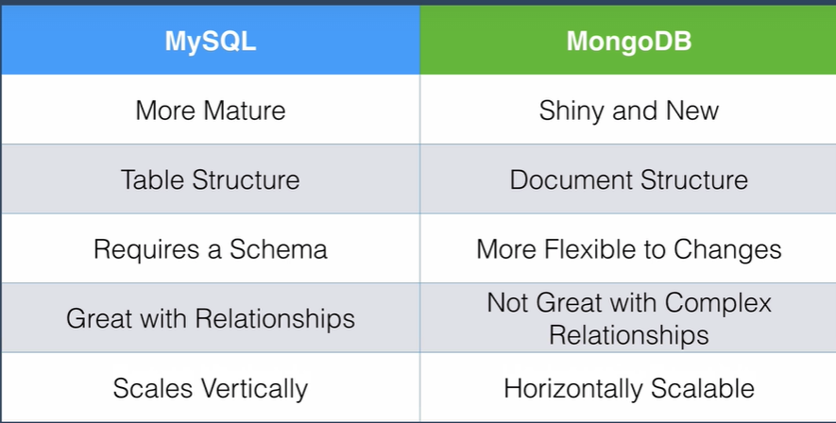

# ****Limitations of Relational Database(My SQL)****

# 



# ****Advantages of Non-Relational Database (MongoDB) :****

# 

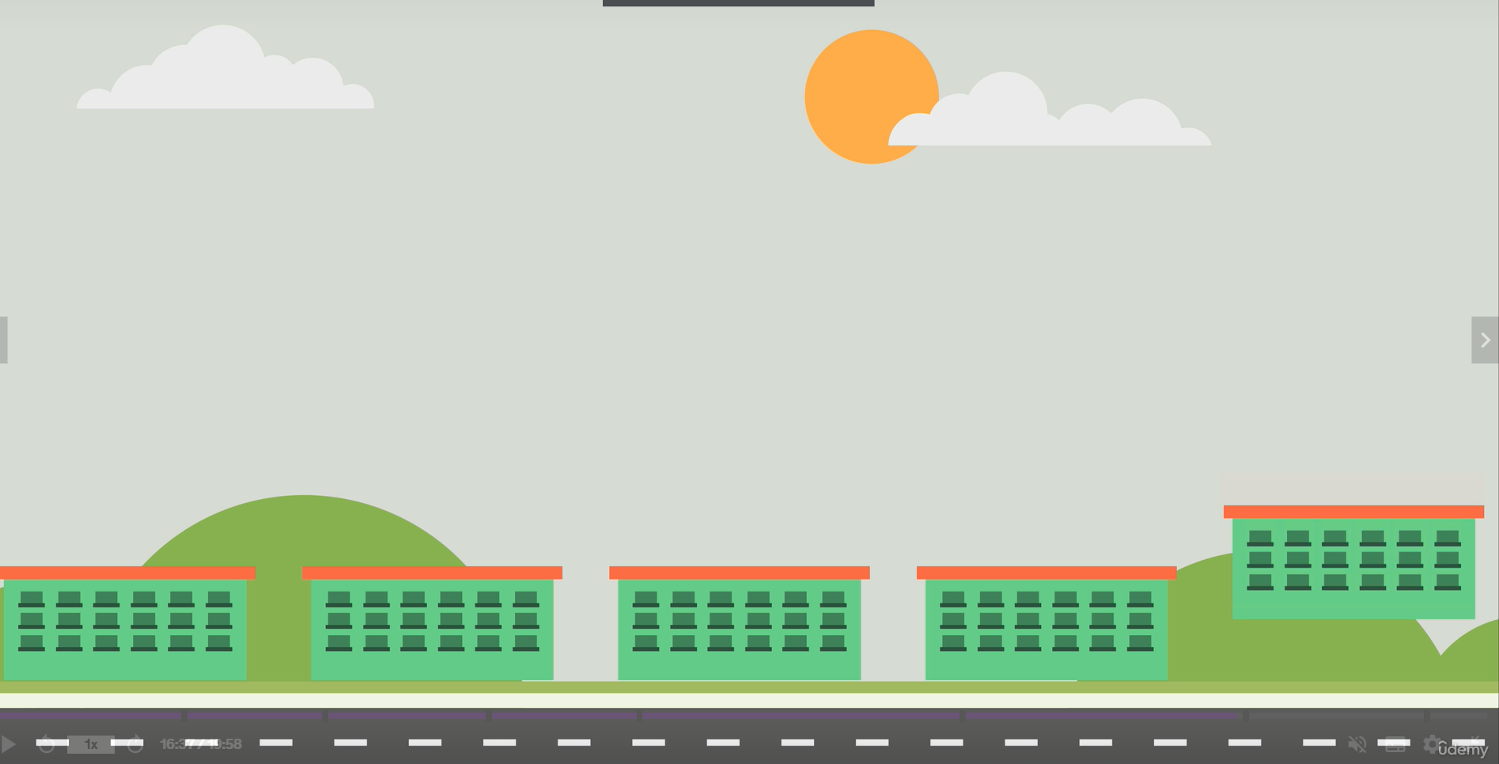

# ****Why Use MongoDB :****

* Fast – Being a document-oriented database, easy to index documents. Therefore a faster response.
* Scalability – Large data can be handled by dividing it into several machines.
* Use of JavaScript – MongoDB uses JavaScript which is the biggest advantage.
* Schema Less – Any type of data in a separate document.
* Data stored in the form of JSON –
  1. Objects, Object Members, Arrays, Values, and Strings
  2. JSON syntax is very easy to use.
  3. JSON has a wide range of browser compatibility.
  4. Sharing Data: Data of any size and type(video, audio) can be shared easily.

# ****Drawbacks:****

### Adding some codes manually can slow down the execution of the web application and affect its overall performance.

* MongoDB is not good at relationships

# ****Conclusion:****

The demand for web developers has grown over 8 percent in the last decade. Web technology keeps advancing each day and there is a growing demand for seamless and enriching web applications. Developers have built different technology through which one can build interactive and responsive web applications. Popularly, web developers use Javascript and HTML to work on advanced technology like the MERN stack which is used to build highly robust full stack applications.In this article we will understand what the MERN stack is, and more about this popular and trending javascript stack.